Chapter 6 Late Middle Ages Vocab Terms

1. Barbette - Debbi Wright

In our textbook the barbette is defined as a “linen band that passed down from one temple under the chin and up to the other temple.” This was usually worn with other head coverings. ‘ The French word *barbe* means beard, so the band worn by women resembles a female beard, thus a “barbette.”’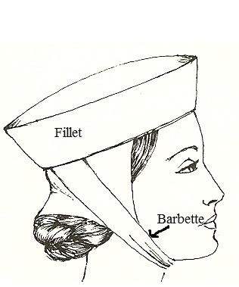

Toratora, Phyllis G, and Keith Eubank. *Survey of Historic Costume, 5th Edition*. Berg, 2009.

<https://fashionhistory.fitnyc.edu/barbette/#:~:text=A%20piece%20of%20linen%20which,coverings%20during%20the%20Middle%20Ages.&text=So%20the%20barbette%20is%20most,linen%20band%20under%20the%20chin>.

<https://www.google.com/search?q=barbette+middle+ages&sxsrf=APq-WBtxflZy82o6vXFMxH3pURGJwyWtPw:1643649779469&source=lnms&tbm=isch&sa=X&ved=2ahUKEwil2PXJwNz1AhU1O30KHUFjBQsQ_AUoAXoECAEQAw&biw=1366&bih=625&dpr=1#imgrc=yUBd2o4BogS5nM>

1. Bowl Crop - Savannah Jeppson

The bowl crop was a hairstyle worn by men named by historians because of its look as an inverted bowl atop the head. Which actually, was how it was cut. The barber would place a bowl around the head and shave the sides and back. Later it would be called the pageboy cut. The length changed from being super short and close shaved at the neck, to longer around the ears.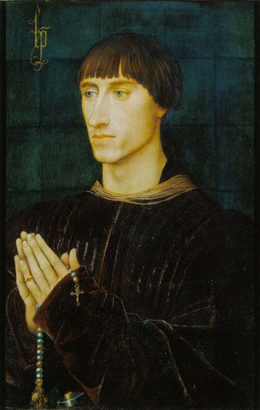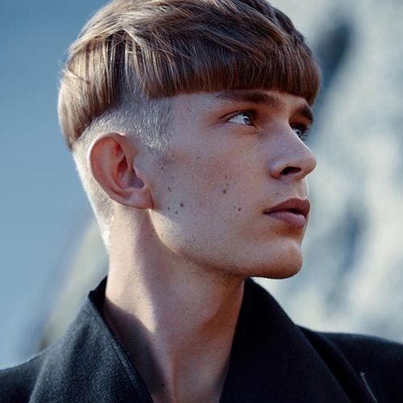

Sources:

The Book

<https://menhairstylesworld.com/mens-hairstyles-through-the-ages/>

<https://www.encyclopedia.com/fashion/encyclopedias-almanacs-transcripts-and-maps/bowl-haircut>

1. Coat of Plates: Abbie Burns 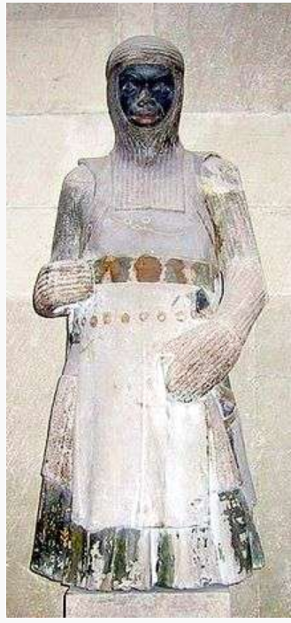

A cloth covered in large ridged plates. It first began with only solid metal plates covering the legs, elbows and knees. Later on in the 3rd century the trunk armor was added. Traditionally worn with a “mail hauberk and a helmet”. The metal armor was sewn in place. The construction consisted of metal overlapping inside the cloth. This was worn as the “full knightley harness.”

Sources:

https://ipfs.fleek.co/ipfs/QmXoypizjW3WknFiJnKLwHCnL72vedxjQkDDP1mXWo6uco/wiki/Coat_of_plates.html

https://military-history.fandom.com/wiki/Coat_of_plates

Book pg: 169

1. Corset-Ida Johnson

The first true corset was invented in 1500-1550. Corsets are made out of rigid materials such as whalebone, horn, and buckram and are referred to as "whalebone bodies". A stay or busk is placed vertically in the center of the torso to keep it straight. Commonly worn with shoulder straps, the corset extends the length of the torso, stopping just above the pelvic bone. The corset is an article of clothing worn to shape or constrict the waist and support the bosom, whether as a foundation garment or as outer decoration. During the early eras of corsetry, corsets—called stays before the 19th century and made stiff with heavy boning—molded a woman’s upper body into a V-shape and flattened and pushed up the breasts.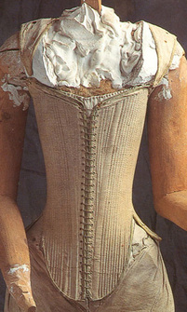

<https://www.famsf.org/blog/corsets-context-history> <https://www.britannica.com/topic/corset>

1. Cote-hardie- Andrea Lazaro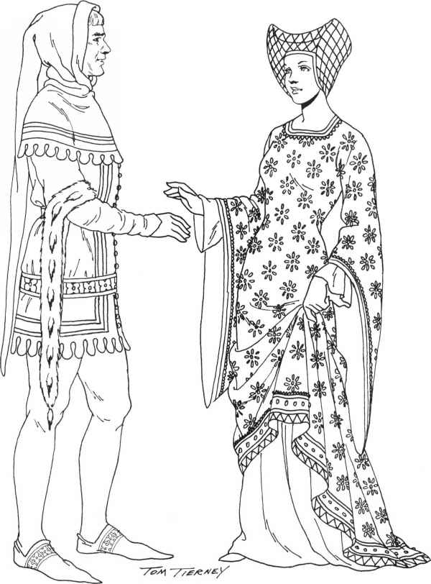

The cote-hardin was used differently depending on the country. However, the basic structure consisted of a long garment, buttoned on the front, and belted on the waist; the lower part of the cote-hardie was sewn to a skirt. The sleeves were long to the elbow and decorated with extensions in the back of the sleeves. The cote-hardie was first worn by lower class people, and later by first class.

Sources:

* Survey of Historic Costume page 152.
* <https://www.worldhistory.org/article/1248/clothes-in-medieval-england/>
* <https://bellatory.com/fashion-industry/FashionHistoryoftheHIghandLateMiddleAgesClothingo-the11th-15thCentury>

1. Crackowe: Elizabeth Nathan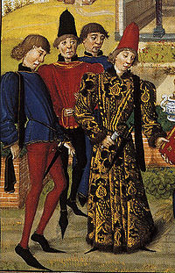

Crakows or crackowes were a style of shoes with extremely long toes very popular [in 15th century Europe](https://en.wikipedia.org/wiki/1400%E2%80%931500_in_European_fashion). They were so named because the style was thought to have originated in [Kraków](https://en.wikipedia.org/wiki/Krak%C3%B3w), then the capital of [Poland](https://en.wikipedia.org/wiki/Poland). They are also known as poulaines or pikes. Long-toed shoes had been popular in Europe at different times, first appearing in the archeological record in the 12th century and falling in and out of fashion periodically. They reached their most exaggerated form in the third quarter of the 15th century before falling out of fashion in the 1480s.The pointed toes of crackowes varied in length from six inches to twenty-four inches, and gentlemen often stuffed the toes with hay or inserted whalebone supports to hold up the long ends.

<https://en.wikipedia.org/wiki/Crakow>

<http://www.fashionencyclopedia.com/fashion_costume_culture/Early-Cultures-Europe-in-the-Middle-Ages/Crackowes-and-Poulaines.html>

1. Dagging-Abigail Storrer

Dagging was used in the 14th century to decorate the edges of garments. It was done by cutting the edge into shapes that could be complicated or simple including v shapes and scallops. Dagging was done on both mens and womens clothes including sleeves, cloaks, skirts, and even on other items such as the caparison, which was a cloth covering put on a horse. 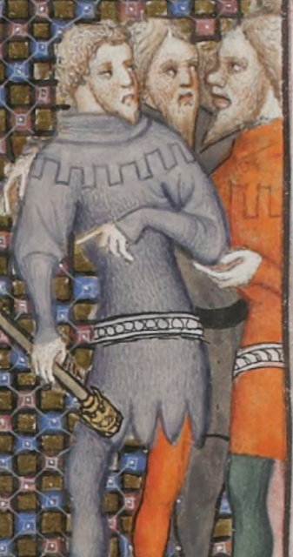

Tortora, P. G., & Eubank, K. (2010). *Survey of historic costume: A history of western dress*. Fairchild.

<https://fashionhistory.fitnyc.edu/dagging/>

<https://www.martelnyc.com/history-costume/dagging-and-slashing.html>

1. Doublet- Hailey child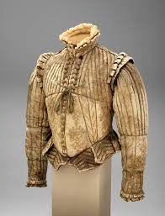

A doublet is a close fitting, padded jacket worn typically by men. Usually hip or waist length, it was worn under another article of clothing such as a tunic, mantle or a gown. It provided warmth, comfortability, fashionable shape and padded security. Also used in the practice of fencing, with all the padding. They were fastened in the front with either buttons or laces and typically had standing neckbands.

<https://en.wikipedia.org/wiki/Doublet_(clothing)>

Book <https://fashionhistory.fitnyc.edu/doublet/>

1. Footed Hose- Anna Ament 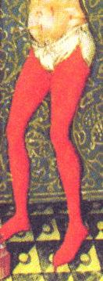

Hose was a form of tights worn by men and women in the late medieval stages. However, the footed hose was worn most commonly by men. Hose was made from linen and wool, and men specifically wore very tight hose to accentuate the muscles in their legs. As time developed, new techniques were created with knitting and other fabrics to highlight the legs even more. They were worn in many different colors and eventually became the specialty of some tailors. At times the footed hose was held up by garters, bands around the waist, and eventually became connected.

<https://rosaliegilbert.com/hose.html>

<https://www.encyclopedia.com/sports-and-everyday-life/fashion-and-clothing/clothing-jewelry-and-personal-adornment/hose-and-breeches>

1. Fret-jamie rakes 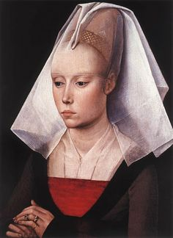

A fret as told in the textbook is essentially a net. This fret was worn under a narrower fillet. As I was researching frets and trying to find out more information about them the only thing I was able to find was on different dictionary sites. At first I imagined a fret to be like a fishing net material like rope or twine. However according to the definitions I found it was actually made of wire! I find this fascinating as you can tell from the picture you can see part of the fret worn underneath the narrower fillet.

Textbook page 109

<https://www.ahdictionary.com/word/search.html?q=fret>

<https://www.thefreedictionary.com/fret>

1. Gambeson - Jessica Fraser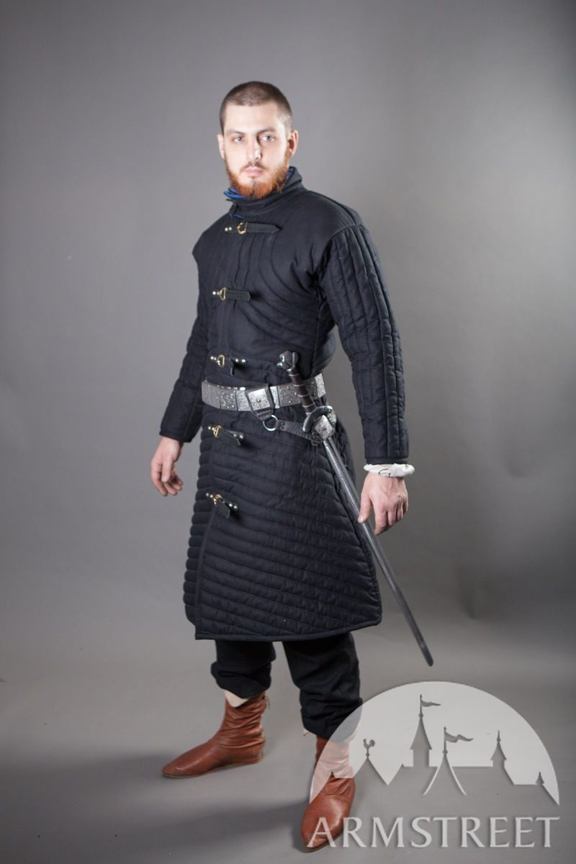

These jackets were quilted and used as a padded jacket for defense. You could wear it with armor or alone. They were very warm and made up of many layers. I found it interesting that they had so many layers of clothing and different clothing for new activities. They must have had to wash and take care of many items.

Sources:

The Book

<https://en.wikipedia.org/wiki/Gambeson#:~:text=A%20gambeson%20(also%20aketon%2C%20padded,a%20sewing%20technique%20called%20quilting>

[(Links to an external site.)](https://en.wikipedia.org/wiki/Gambeson#:~:text=A%20gambeson%20(also%20aketon%2C%20padded,a%20sewing%20technique%20called%20quilting)

<https://its-spelled-maille.tumblr.com/post/175518038999/what-is-a-gambeson>

1. Gipon- Jensen Stenquist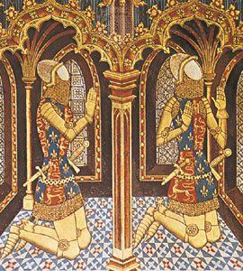

Also called a pourpoint or a doublet. It is a close-fitting, sleeveless garment with a padded front originating as military dress. Padded garments were worn alone as armor by ordinary soldiers, as padding under armor, or over armor after the turn of the century. Later in the century the gipon became shorter, and it was replaced by the [doublet](https://www.britannica.com/topic/doublet-clothing) in the 15th and 16th centuries. For a time it was called a pourpoint.

<https://www.britannica.com/topic/gipon>

<https://www.dictionary.com/browse/gipon>

The Book

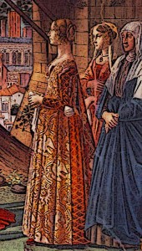

1. Gown - Marisa Bone

Women began to wear tighter tunics and a long flowing gown thrown over it. These gowns were made of five major components; leather, linen, wool, silk and fur. This both increased warmth and style. They closely followed the lines of the body from shoulder to below the waist with a seperate and fuller skirt sewn into the bodice.

[Source 1](https://www.medievalchronicles.com/medieval-clothing/late-medieval-clothing/) [Source 2](https://bellatory.com/fashion-industry/FashionHistoryoftheHIghandLateMiddleAgesClothingo-the11th-15thCentury)

1. Haubergeon - Abby Fluckiger

Part of a knight’s costume. “Haubergeon” can refer to two things: a shorter coat of mail, the “little hauberk”, put on over the gambeson and under the coat of plates and the surcoat – or a quilted undergarment worn under the hauberk, like the gambeson. Worn until the second half of the 1400s, according to the textbook.

Textbook page 172-173

<https://en.wikipedia.org/wiki/Hauberk>

http://myarmoury.com/talk/viewtopic.18746.html

1. Hennin- Brittany Pocock

A hennin was a cone hat that women wore usually with a veil attached to it as well. It would typically range from 30 to 40 cm high but could also be as high as 80cm. It was worn tilted backwards and made from a light material. Some people believe that the word Hennin was not a fashion term but a word used to poke fun at the extreme style. The word hennin can be used for any of the headwear in this period but most recognize it as the cone shaped hat.

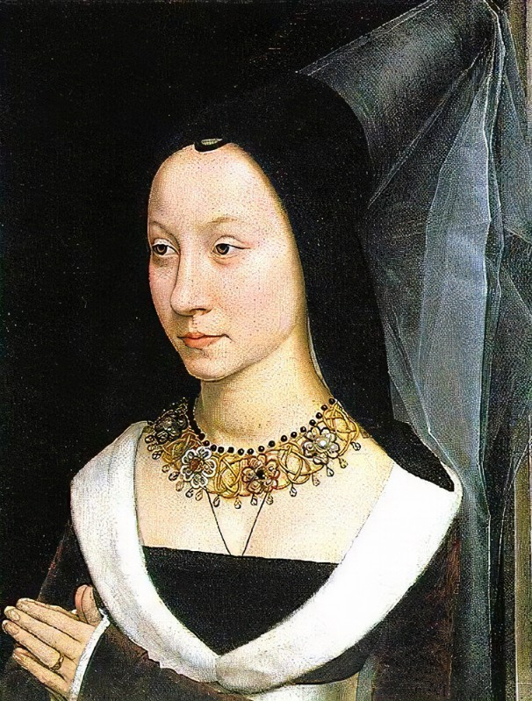

[Hennin - Wikipedia](https://en.wikipedia.org/wiki/Hennin#:~:text=In%20the%20actuallity%20and%20thanks%20to%20characters%20or,white%20veils%2C%20one%20reaching%20down%20to%20the%20face.)

[Rosalie's Medieval Woman - Medieval Hats and Hennins (rosaliegilbert.com)](https://rosaliegilbert.com/hatsandhennins.html)

Page 148

1. Houce, Housse - Kimberly Tesam Moita

New forms of the ganache, herigaut and varied capes and cloaks. The houce or housse was a wide skirted overcoat with caped winged sleeves and two flat, tongue-shaped lapels at the neck. It appeared to be a French variation of the garnache which also had the tongue-shaped tabs. It might be that the religious people of this time wore this more often as you can see different arts with religious or prominent figures in the houce more often.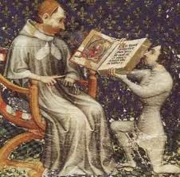

<http://people.ucalgary.ca/~scriptor/cotton/SGGK%20Draft%20to%20Fitt%20Two.pdf>

Survey of Fashion History: *fifth edition,* Phyllis G Tortora, Keith Eubank.

http://ash.heraldry.ca/issues/2010/ASH_3d-Boulton-Intro_IIA.pdf

1. Houppelande- Marisol Dejesus

A houppelande is an outer garment of a full length skirt with a long wide sleeve. Sometimes it has a slit in it to form vents and sometimes has fur lining. It was first mentioned in France royal inventories in 1359 then later became an important garment to England. It was put over the head and fitted over the shoulder, so the style was suited for heavy fabric. It was worn by both women and men. The difference between the women and the men is that the women's houppelande was belted beneath the bust, while the man was belted at the waist. 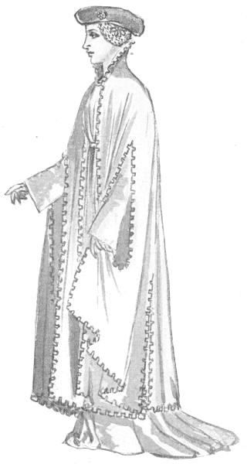

Sources:

Book Pg. 153

<https://www.merriam-webster.com/dictionary/houppelande>

<https://en.wikipedia.org/wiki/Houppelande>

1. Houppelande a mi jambe - Esther Wambold

A houppelande a mi jambe is a mid-calf version of the houppelande that appeared in the 1400s. The houppelande is made from four long pieces of fabric sewn together at the sides, front and back. They were put on over the head and often fur-trimmed. Most had a high collar. They were worn by men and women.

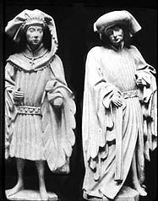

*Dictionary*. (2022). Www.dictionary.com. <https://www.dictionary.com/browse/houppelande>

‌*Rosalie’s Medieval Woman - Houppelandes*. (2022). Rosaliegilbert.com. <https://rosaliegilbert.com/houppelandes.html>

Survey of Historic Costume Pg. 153

(2013). Pinterest; Pinterest. <https://www.pinterest.com/pin/530791506053136745/>

1. Huke- Savannah Tanner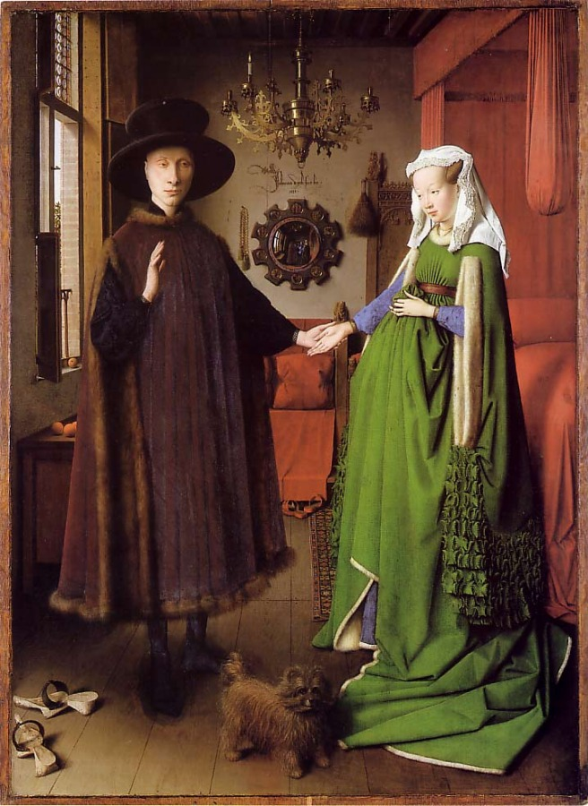
   1. The huke was a garment worn by men, prominently. It was designed to cover armor, and was open on the sides of the garment. Occasionally, there were also slits on the front to assist with horse riding. Hukes were usually worn without a belt. Hukes typically were one color and did not have patterns. Much of the time, the inside was lined with fur as well.
   2. <https://www.coroflot.com/annipeng1/Fashion-Influence-The-Middle-Ages>
   3. <https://lowelldesigns.com/the-gothic-period-medieval/>
   4. Pg 161
2. Jacket: Kya Boyd

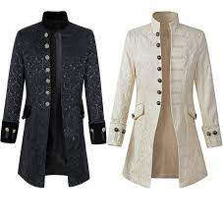

During the early 15th century the cote-hardie was replaced by a jacket also known as a shorter houppelande. The jacket style was still similar in function to the modern suit jacket, but with different cuts and worn with hose instead of trousers. Jackets stayed in fashion becoming an important garment. The jackets are deeply rooted in the military or any navy background to associate how important the person is.

Sources: <https://alitools.io/en/showcase/middle-ages-prince-punk-steampunk-jacket-long-sleeve-retro-men-s-uniform-costumes-coat-steampunk-retro-halloween-cosplay-32897445502>

Book

<https://www.castlesandmanorhouses.com/life_03_clothing.htm>

1. Livery- Claire Moore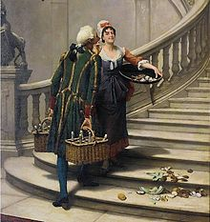

A livery is a special uniform that was distributed and given to servants or officials. In the 14th and 15th century it was worn by officials of the court, and ladies in waiting. This was provided by someone with rank or higher status.

Sources-

<https://www.dictionary.com/browse/livery>

<https://www.collinsdictionary.com/us/dictionary/english/livery>

Page- 148

1. Mi-parti - Jocelyn Munoz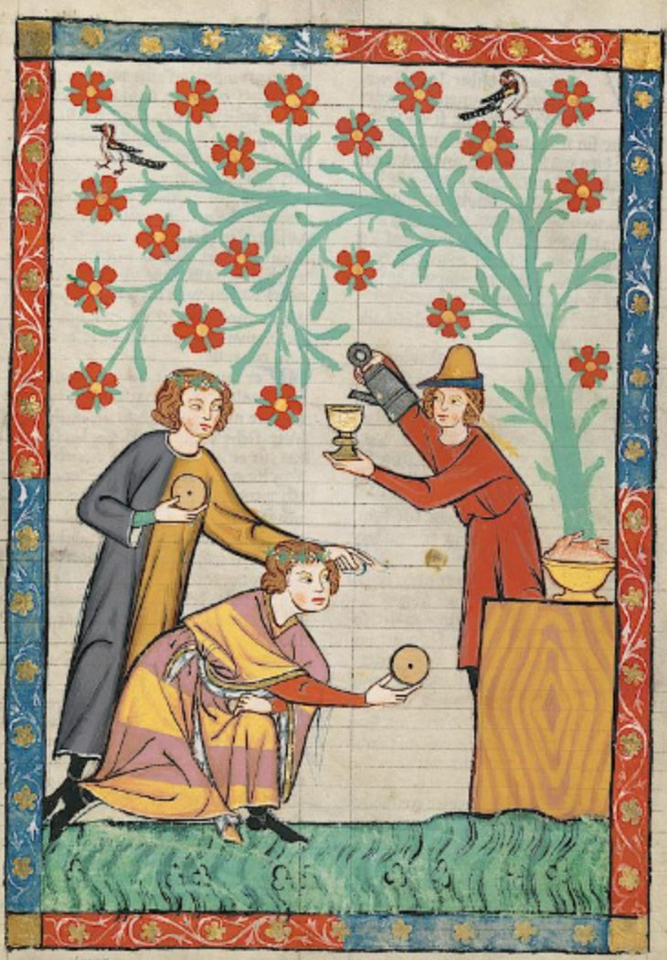

The Mi-parti is just a way of saying multiple colors and such it’s a garment composed of multiple colors. Usually the method was one half or a quarter of a design was created in a different color.

Worn by both men and women when colors were combined in certain ways it could sometimes represent a city one was from or even what family.

Tortora, P. G., & Marcketti, S. B. (2021). In Survey of historic costume. essay, Fairchild Books.

https://fashionhistory.fitnyc.edu/particolored/

https://athenaeum.baronyofmadrone.net/exhibits/the-many-mi-parti-variations-in-14th-century-medieval-manuscripts/

1. Mourning Costume-Jalissa Cloward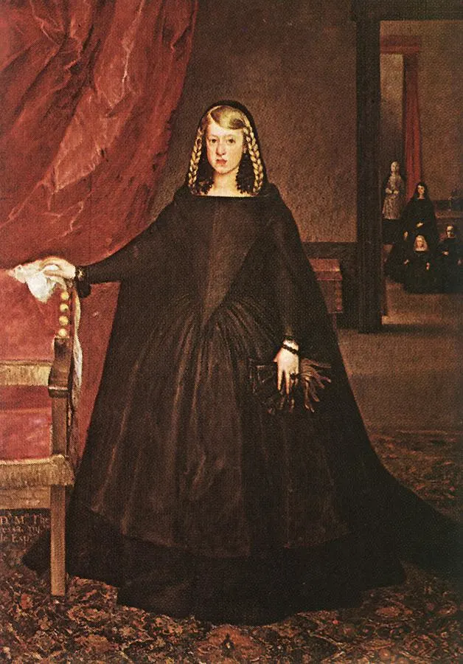

Black first started to be worn as a sign of mourning in the 1300s. Both men and women would wear black or dark, drab colors during the mourning period. Clothing would be simple. Men would wear long, black robes instead of shorter robes and jackets. In the 1400s, widows would wear wimples.

*Survey of Historic Costume* pg. 168

<https://bellatory.com/fashion-industry/FashionHistoryMourningDressBlackClothingWornDuringBereavement>

<https://www.metmuseum.org/art/collection/search/173904>

1. Page Boy (hair cut) - Amanda Hair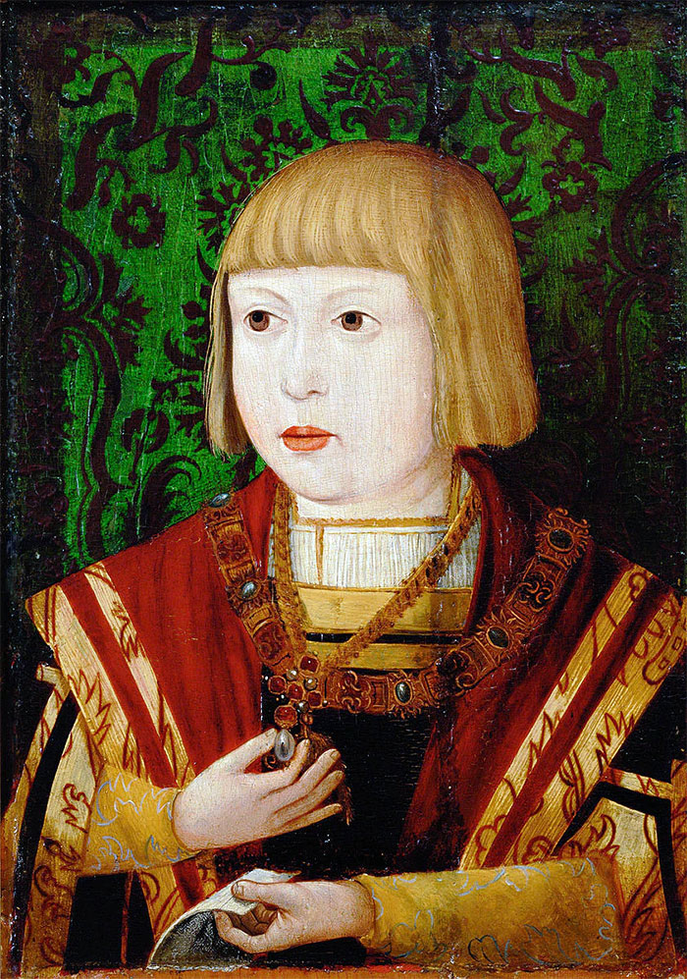

The Pageboy haircut began in the late middle ages but has since then run its course at other times. For example in the late 1050’s-60’s it again became popular. This style is a haircut with a bang on the forehead and the hair curved over the ears up to the neck. It is seen in many art pieces from this time period. Hair was very important at these times as it showed status and position. Before the Pageboy cut the bowl crop was popular. In 1465 things shiften and longer styles became more common. They also wore lots of hair coverings at this time.

<https://thehistoryofthehairsworld.com/middle_ages_renaissance.html>

<https://www.medievalchronicles.com/medieval-clothing/medieval-hairstyles/>

Survey of Historic costume Pg. 161

1. Parti-colored-Hannah Ferreira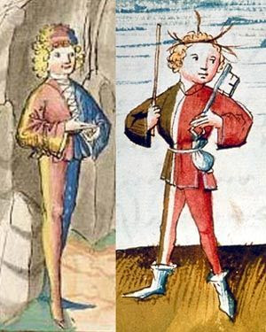

The people of this time period searched for unique patterns or symbols to be associated with their family, and with that came the practice of sewing together sections of different colored fabrics withing one garment. Garments decorated this way were called mi-parti or parti-colored (148). These combination of colors were combined along the vertical axis.

Book

<https://fashionhistory.fitnyc.edu/particolored/>

<http://www.larsdatter.com/particolor.htm>

1. Pattens - Alex Clark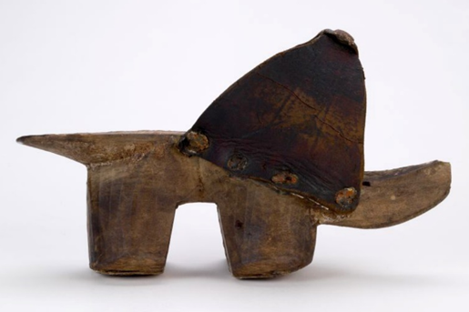

Pattens were raised wooden platforms that were fastened to the foot with a strap and were used primarily during bad weather and terrain. They typically were worn over the person’s original shoe and were worn mostly by working-class women. There were also multiple types of pattens that consisted of wooden platforms that were raised with wooden wedges or iron stands, regular flat wooden platforms, and layered leather platforms.

Sources:

Survey of Historic Costume, Page 162

<https://twonerdyhistorygirls.blogspot.com/2014/01/foul-weather-footwear-pattens.html>

<https://en.wikipedia.org/wiki/Patten_(shoe)>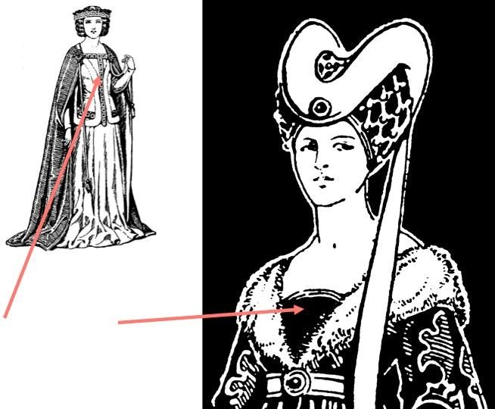

1. Placard- Lauren Shumway

A placard is the English word for Plastron which is a stiffened panel with a rounded lower edge that ends at the hip where it would be belted together it would sometimes be trimmed with fur and highly decorated fabric

The book

<https://www.britannica.com/topic/dress-clothing/Medieval-Europe>

<http://www.thefashionhistorian.com/2011/03/head-to-toe-14th-century-woman.html>

1. Plastron- Lena Kawakami in French plastron means “front shirt”. This is found on historical uniforms and traditional costumes. insert can be found on historical uniforms and traditional costumes. It’s workby men and typically covers the breast area it could be worn by dancers or riders . <https://historicalsewing.com/1890s-plastrons-is-that-a-victorian-bib> clothing.<https://www.muellerundsohn.com/en/allgemein/pattern-construction-plastron-shirt/> <https://www.muellerundsohn.com> 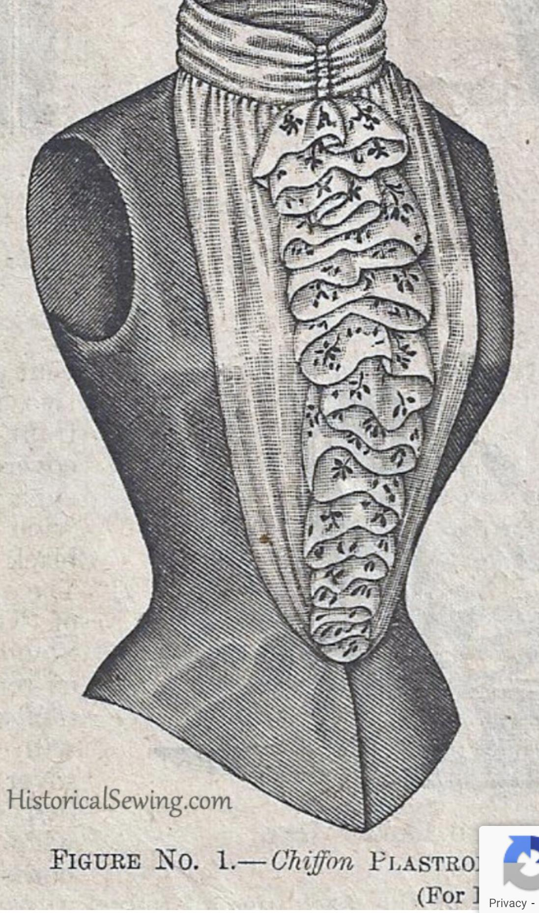
2. Pattern Construction Plastron Shirt - M.Müller & Sohn
3. Points- Zaya Weight

Points were essentially laces used to suspend various other garments in place. They were made of leather or sturdy cord & had metal tips or aglets which could be plain or decorative. Their primary use was to suspend the hose from the doublet by way of eyelets sewn in the top edge of the hose, but they were also used in military kit to suspend the cuisses (thigh plates), which in turn supported the rest of the leg harness, as well as spaulders (shoulder armor) which supported the arm harness. The cuisses & spaulders had small tabs of leather riveted to the inside that had holes for the points to tie to. Cuisses were suspended either by points either from the bottom of the arming doublet itself or by a separate belt or harness made of sturdy linen or leather. The spaulders were suspended by points sewn directly into the shoulders of the arming doublet that slipped up through the rings of mail that was worn under plate to protect gaps.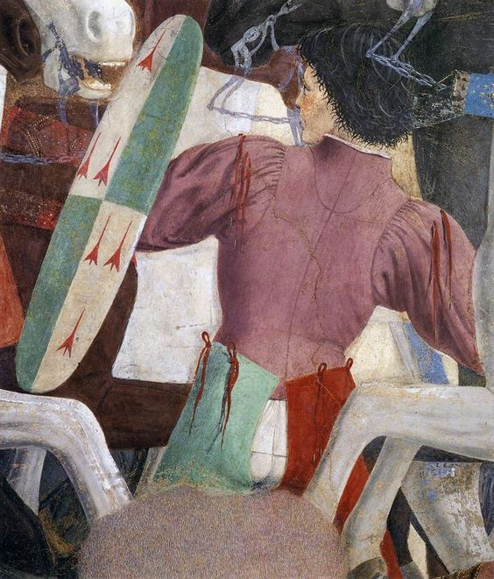

**Sources:**

Survey of Historic Costume - page 159

The Medieval Tailor’s Assistant - page 79

Armour of the English knight 1400-1500 - page 134

[Knight Errant](https://www.youtube.com/channel/UC1T4KJG1L_kTrP9RcdU5Csw)

1. Poulaine - Irelynd Preece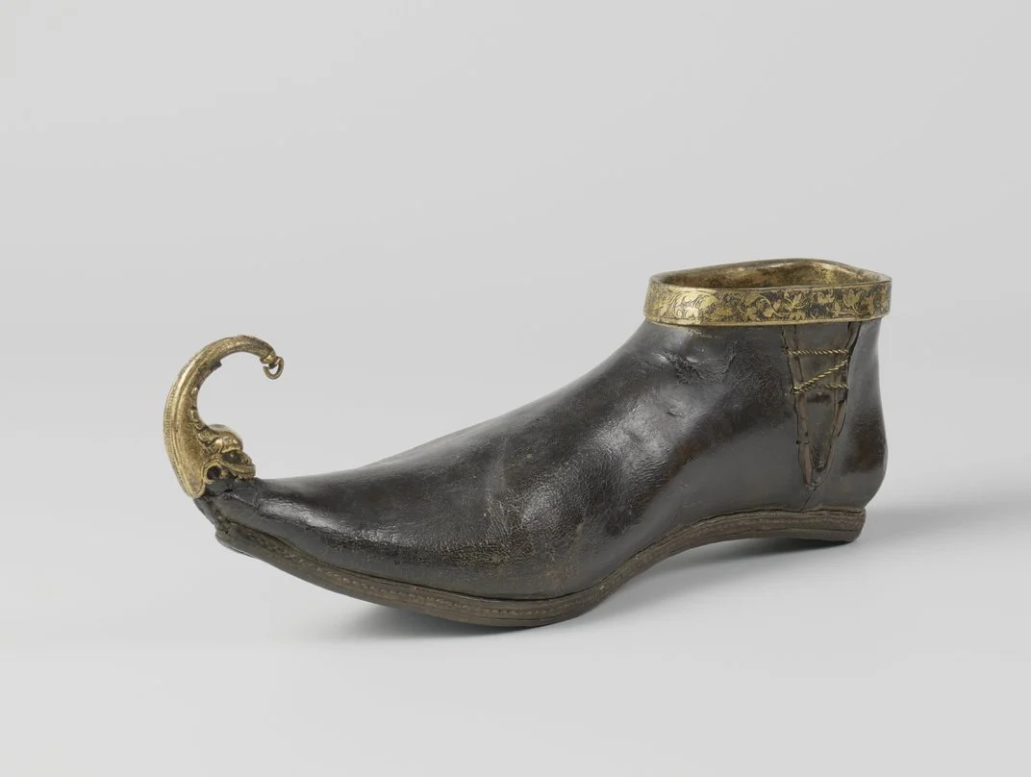

The poulaine was an elongated pointed toe shoe. The style of the shoe was called Krakow and the poulaine part was the long end of the shoe. At times it could be so long that a string had to be attached to the end of it and tied around the knee to keep the wearer from falling. The reason they wanted these shoes was due to them clearly impairing the wearer from walking well which meant they weren’t going to be partaking in any form of physical labor. So also being an indicator of leisure and luxury.

Sources:

Textbook pg. 154

<https://fashionhistory.fitnyc.edu/poulaine/>

<https://www.atlasobscura.com/articles/medieval-europeans-pointy-shoes>

1. Pourpoint- **Ryann Becker**

This was also called a doublet or gipon. It was a fitted garment that was sleeveless and padded. It was used for military dress and was worn under armor. However it did begin to be worn with sleeves for civilians. The way the garment was attached was by laces that had small metal tips or points. That is where the garment got its name; it means “for the points.” 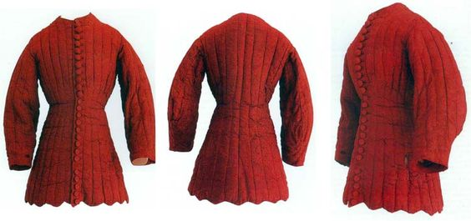

Textbook page 151

<http://web.ceu.hu/medstud/manual/SRM/male.htm#:~:text=The%20pourpoint%20was%20an%20overgarment,mail%20hauberk%20worn%20under%20it>.

<http://www.fashionencyclopedia.com/fashion_costume_culture/Early-Cultures-Europe-in-the-Middle-Ages/Pourpoint.html> 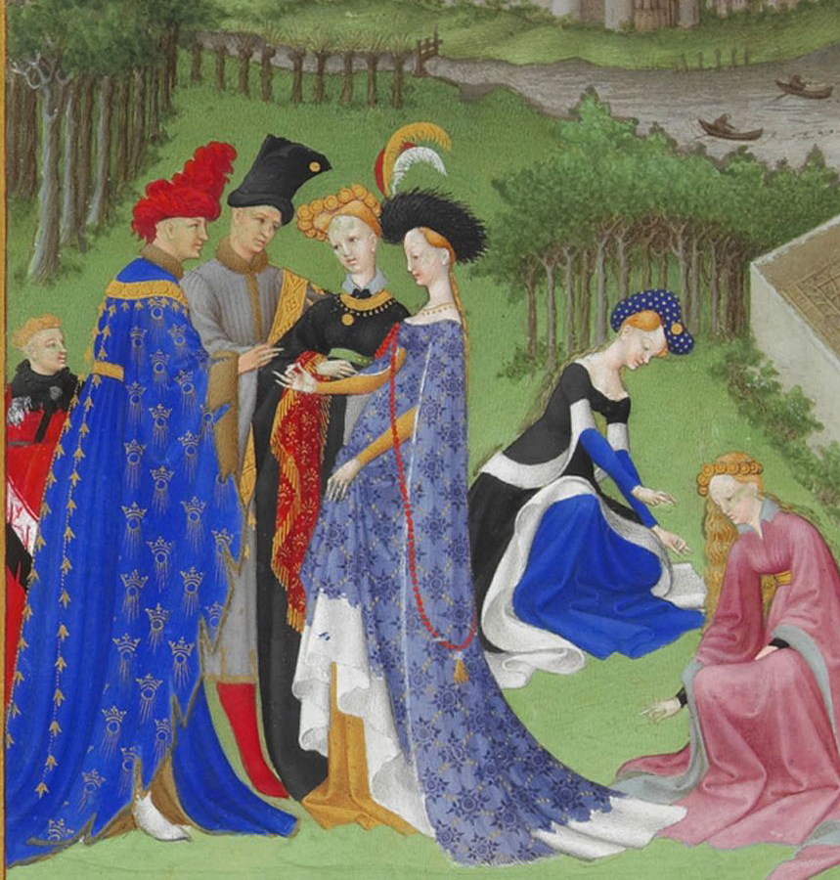

1. Roc- Samantha Hooper

The roc was a unfitted, loose gown. Seemingly not very common, they really only appear in German or Flemish paintings. They were floor length and sleeves could be long or short. They had a rounded neckline and were pleated in the front and back center. Roc is possibly another word for frock.

Book

<https://fashion-history.lovetoknow.com/fashion-history-eras/europe-america-history-dress-400-1900-c-e>

https://en.wikipedia.org/wiki/1400%E2%80%931500_in_European_fashion

1. Shift - Bailey Pinder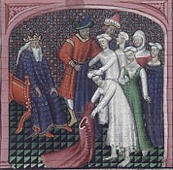

Shifts are also called chemises or smocks.They were the main womens undergarment for hundreds and hundreds of years. In france they were referred to as chemises and in England they were called smocks. They were the undermost garment put on, meaning the layer that was closest to the skin .It was worn next to the skin to absorb bodily odors and keep the outer layers smelling fresher for longer. They were almost always made of linen and had very little if any decoration.

<https://rosaliegilbert.com/chemises.html#:~:text=The%20chemise%2C%20shift%20or%20smock%20was%20the%20innermost%20layer%20of,layers%20smelling%20fresher%20for%20longer>.

<http://costumehistorian.blogspot.com/2014/09/smock-shift-chemise.html>

Survey of Historic Costume, pg 163

1. Smock (undergarment) - Aubrey Reidhead

The smock was the base layer for women’s clothing. Everything else was layered above the smock (Pg. 166) “smock, also called chemise, loose, shirtlike [garment](https://www.britannica.com/topic/dress-clothing) worn by women in the European [Middle Ages](https://www.britannica.com/event/Middle-Ages) under their gowns.” At some point the smock evolved into a shirtlike outer garment to protect clothes (Britannica). The smock was the women’s equivalent to a man’s shirt and was usually made of 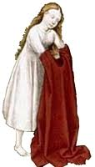white linen (Larsdatter).

<https://www.britannica.com/topic/smock>

<http://www.larsdatter.com/smocks.htm>

1. Custom of buttoning Men’s coat from “left over right” came from what military article of clothing (explain)? Lexie Pincock
2. MADISON FROST LIRIPIPE: A liripipe is the tail of a hood. It also can be on a cloak. There is a modern day liripipe that is used in professional circumstances. It's worn around the neck and pulled in the front.
3. 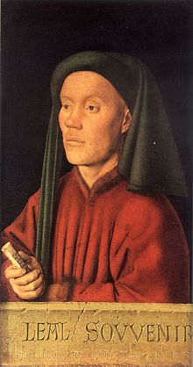

book

<https://en.wikipedia.org/wiki/Liripipe>

[(Links to an external site.)](https://en.wikipedia.org/wiki/Liripipe)

<https://www.britannica.com/topic/liripipe>

38. Sariah Beverley

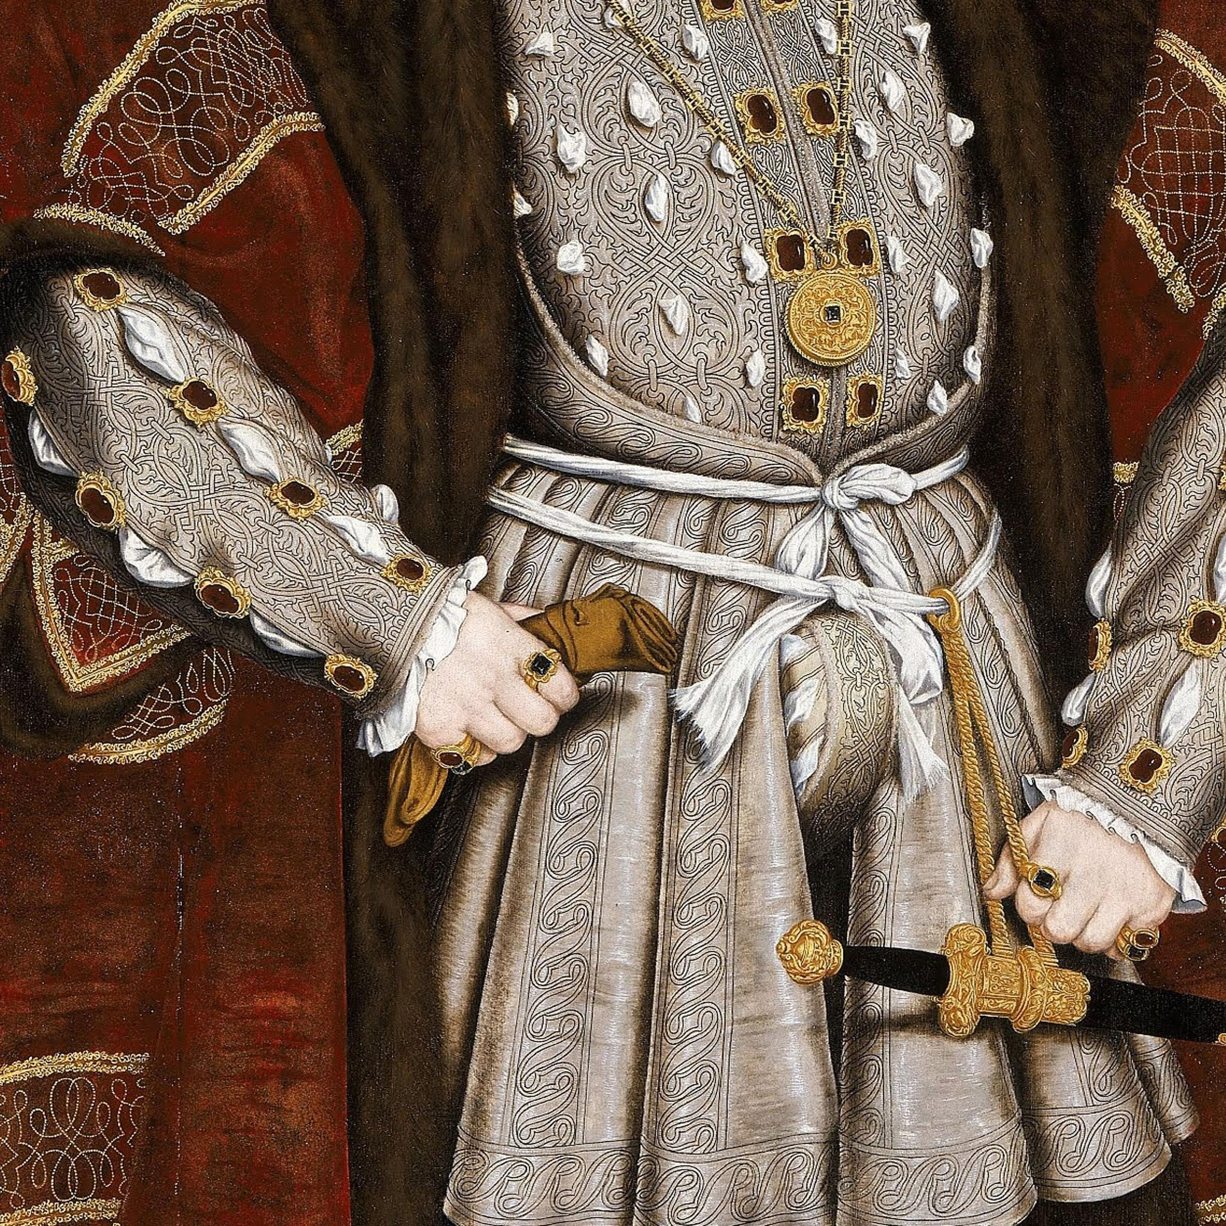

The Codpiece was a sewn accommodation for the mens genitals. They were ties shut with laces and was used as a covering flap. Henry the VIII was the poster boy for codpieces. On occasion it weighed more than 2 pounds. This was created with the idea that it would contain the disease from Europe called syphilis.

[https://fashion-history.lovetoknow.com/fashion-history-eras/europe-america-history-dress-400-1900-c-e (Links to an external site.)](https://fashion-history.lovetoknow.com/fashion-history-eras/europe-america-history-dress-400-1900-c-e)

[(Links to an external site.)](https://fashion-history.lovetoknow.com/fashion-history-eras/europe-america-history-dress-400-1900-c-e)

<https://www.newyorker.com/books/page-turner/a-brief-history-of-the-codpiece-the-personal-protection-for-renaissance-equipment>

[(Links to an external site.)](https://www.newyorker.com/books/page-turner/a-brief-history-of-the-codpiece-the-personal-protection-for-renaissance-equipment)

I found it interesting in the video how the kirtle was based on the Heriolfsnes findings. It has side gores and finger loop braids on the neckline. I enjoyed learning about the history of the Middle Ages to get an idea of the progression of the fashion history.